System Capacity Test - Log TEMPLATE

**Run 1: DBSID99 19990131**

**Run2: DBSID01 20010228**

**DO NOT EDIT TEMPLATE DOCUMENT. Save as a copy using following format**

Open "**System capacity test - Log TEMPLATE - READONLY**" document and save it as   
**System capacity test - Log [dbname run 1] [date YYYYMMDD run 1] [dbname run 2] [date YYYYMMDD run 2]**

Example:  
  
"System capacity test - Log DTCDUAT1 20170324 DTCDUAT 20170418"

# Run 1

## R01-LOG-01 Timestamp of the test

|  |  |
| --- | --- |
| From | To |
| 1999-01-31 01:00:00 | 1999-01-31 02:00:00 |

## R01-LOG-02 ASH Graphs

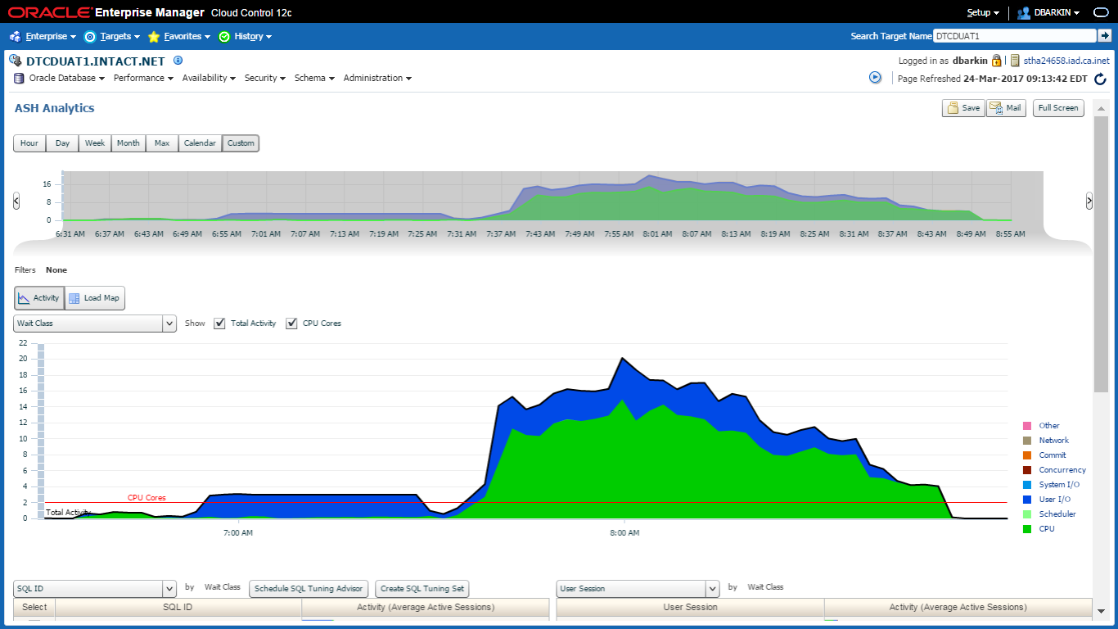

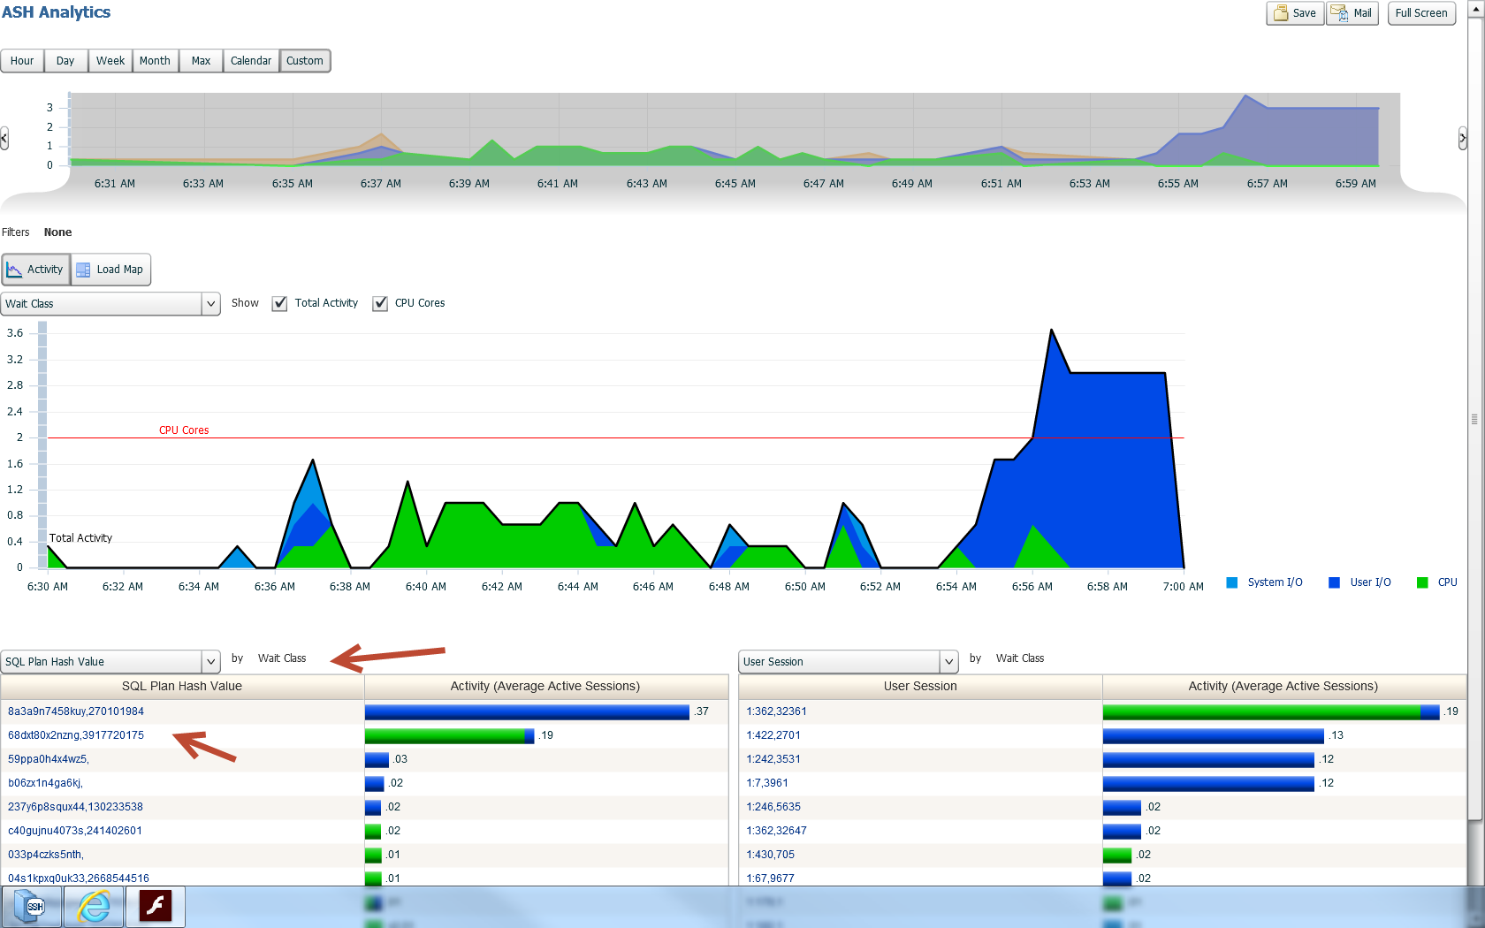

## R01-LOG-03 Current AWR snapshots

|  |
| --- |
| Instances in this Workload Repository schema  ~~~~~~~~~~~~~~~~~~~~~~~~~~~~~~~~~~~~~~~~~~~~  DB Id Inst Num DB Name Instance Host  ------------ -------- ------------ ------------ ------------  * 2557778086 1 DBSID99 DBSID99 stha7n0059  Using 2557778086 for database Id  Using 1 for instance number  Specify the number of days of snapshots to choose from  ~~~~~~~~~~~~~~~~~~~~~~~~~~~~~~~~~~~~~~~~~~~~~~~~~~~~~~  Entering the number of days (n) will result in the most recent  (n) days of snapshots being listed. Pressing <return> without  specifying a number lists all completed snapshots.  Enter value for num_days: 1  758 31 Jan 1999 01:00 2  759 31 Jan 1999 01:30 2  760 31 Jan 1999 02:00 2  761 31 Jan 1999 02:30 2  762 31 Jan 1999 03:00 2 |

## R01-LOG-04 AWR Export Output

|  |
| --- |
| Using the dump file prefix: DBSID99_24972_24975_170217  |  | ~~~~~~~~~~~~~~~~~~~~~~~~~~~~~~~~~~~~~~~~~~~~~  | The AWR extract dump file will be located  | in the following directory/file:  | /nfsrwora/12c_migrate/awrdata  | DBSID99_24972_24975_170217.dmp  | ~~~~~~~~~~~~~~~~~~~~~~~~~~~~~~~~~~~~~~~~~~~~~  |  | *** AWR Extract Started ...  |  | This operation will take a few moments. The  | progress of the AWR extract operation can be  | monitored in the following directory/file:  | /nfsrwora/12c_migrate/awrdata  | DBSID99_24972_24975_170217.log  | |

## R01-LOG-05 AWR Import Output

|  |
| --- |
| |  | ~~~~~~~~~~~~~~~~~~~~~~~~~~~~~~~~~~~~~~~~~~  | Loading the AWR data from the following  | directory/file:  | /nfsrwora/12c_migrate/awrdata  | **DBSID99_24972_24975_170217**.dmp  | ~~~~~~~~~~~~~~~~~~~~~~~~~~~~~~~~~~~~~~~~~~  |  | *** AWR Load Started ...  |  | This operation will take a few moments. The  | progress of the AWR load operation can be  | monitored in the following directory/file:  | /nfsrwora/12c_migrate/awrdata  | DBSID99_24972_24975_170217.log  |  **Using 9931010100 as the new DBID**  ... Dropping AWR_STAGE user |

# Run 2

## R02-LOG-01 Timestamp of the test

|  |  |
| --- | --- |
| From | To |
| 2001-02-28 11:00:00 | 2001-02-28 12:00:00 |

## R02-LOG-02 ASH Graphs

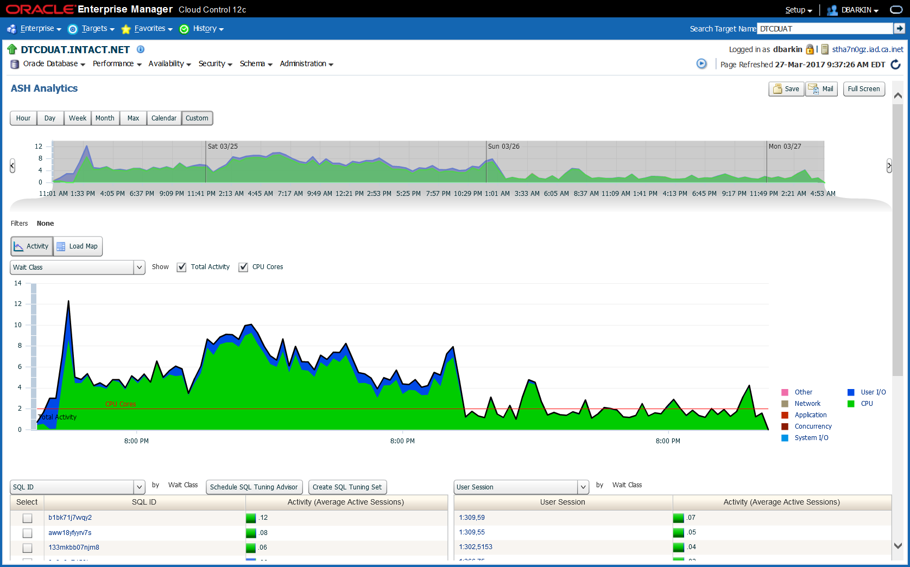

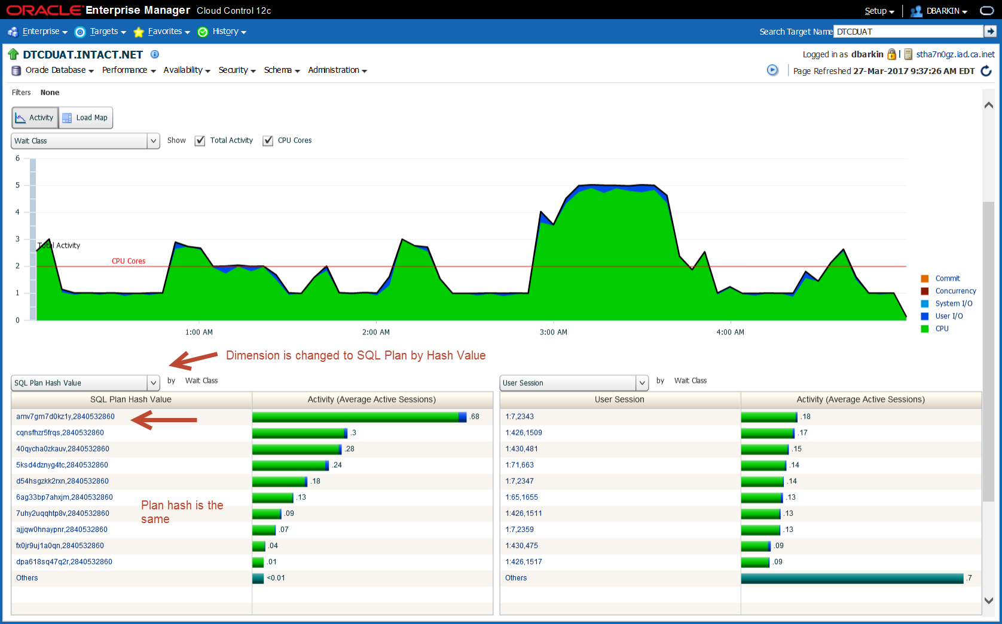

## R02-LOG-03 Current AWR snapshots

|  |
| --- |
| Instances in this Workload Repository schema  ~~~~~~~~~~~~~~~~~~~~~~~~~~~~~~~~~~~~~~~~~~~~  DB Id Inst Num DB Name Instance Host  ------------ -------- ------------ ------------ ------------  * 2210667516 1 DBSID02 DBSID02 stha7n0h0  Using 2210667516 for database Id  Using 1 for instance number  Specify the number of days of snapshots to choose from  ~~~~~~~~~~~~~~~~~~~~~~~~~~~~~~~~~~~~~~~~~~~~~~~~~~~~~~  Entering the number of days (n) will result in the most recent  (n) days of snapshots being listed. Pressing <return> without  specifying a number lists all completed snapshots.  Enter value for num_days: 4  Listing the last 4 days of Completed Snapshots  Snap  Instance DB Name Snap Id Snap Started Level  ------------ ------------ --------- ------------------ -----  DBSID01 DBSID01  360 28 Feb 2001 11:00 2  361 28 Feb 2001 11:30 2  362 28 Feb 2001 12:00 2  363 28 Feb 2001 12:30 2 |

## R02-LOG-04 AWR Export Output

|  |
| --- |
| Using the dump file prefix: DBSID01_360_492_170327  |  | ~~~~~~~~~~~~~~~~~~~~~~~~~~~~~~~~~~~~~~~~~~~~~  | The AWR extract dump file will be located  | in the following directory/file:  | /nfsrwora/12c_migrate/awrdata  | DBSID01_360_492_170327.dmp  | ~~~~~~~~~~~~~~~~~~~~~~~~~~~~~~~~~~~~~~~~~~~~~  |  | *** AWR Extract Started ...  |  | This operation will take a few moments. The  | progress of the AWR extract operation can be  | monitored in the following directory/file:  | /nfsrwora/12c_migrate/awrdata  | DBSID01_360_362_170327.log |

## R02-LOG-05 AWR Import Output

|  |
| --- |
| ... Creating AWR_STAGE user  |  | ~~~~~~~~~~~~~~~~~~~~~~~~~~~~~~~~~~~~~~~~~~  | Loading the AWR data from the following  | directory/file:  | /nfsrwora/12c_migrate/awrdata  | DBSID01_360_492_170327.dmp  | ~~~~~~~~~~~~~~~~~~~~~~~~~~~~~~~~~~~~~~~~~~  |  | *** AWR Load Started ...  |  | This operation will take a few moments. The  | progress of the AWR load operation can be  | monitored in the following directory/file:  | /nfsrwora/12c_migrate/awrdata  | DBSID01_360_492_170327.log  |  Using **0102281100** as the new DBID  ... Dropping AWR_STAGE user |

# Compare

## R03-LOG-01 Runs to be compared

|  |
| --- |
| 9931010100 DBSID99 stha7n005 AIX-Based 757 762 24-MAR-17 06.00.03.331 AM 24-MAR-17 08.30.23.013 AM  0102281100 DBSID01 stha1111 AIX-Based 360 362 24-MAR-17 10.30.12.007 AM 27-MAR-17 04.30.08.543 AM |